Level 1.4: STM32CubeIDE Environment
Starting Level 1.4
Theory + practical orientation
Our target is to understand the STM32CubeIDE environment, while keeping Keil µVision as our primary coding IDE.
1. What is STM32CubeIDE?
STM32CubeIDE is an integrated development environment (IDE) provided by STMicroelectronics for developing STM32 firmware.
It combines several tools:
Component | Purpose
Code editor | Write and edit C code
STM32CubeMX | Configure MCU peripherals and clocks
Compiler | Convert C code into object code
Linker | Combine object files and arrange memory sections
Debugger | Debug firmware on supported hardware
Project explorer | Organize project files
Console | Display build and debugging messages
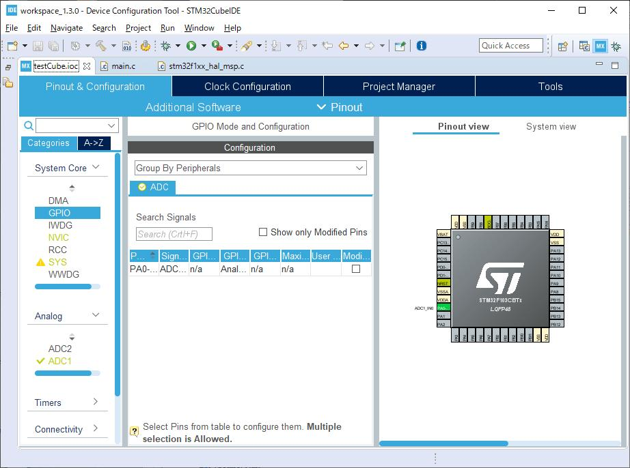
Typical STM32CubeIDE workspace. The exact layout varies by version.
2. Understanding the main areas
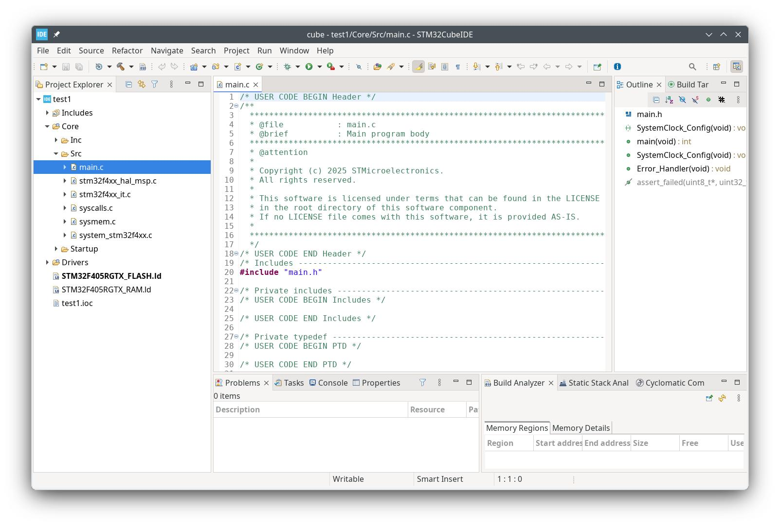
Project Explorer
Displays project folders and files, such as Core, Drivers, main.c and the startup files.
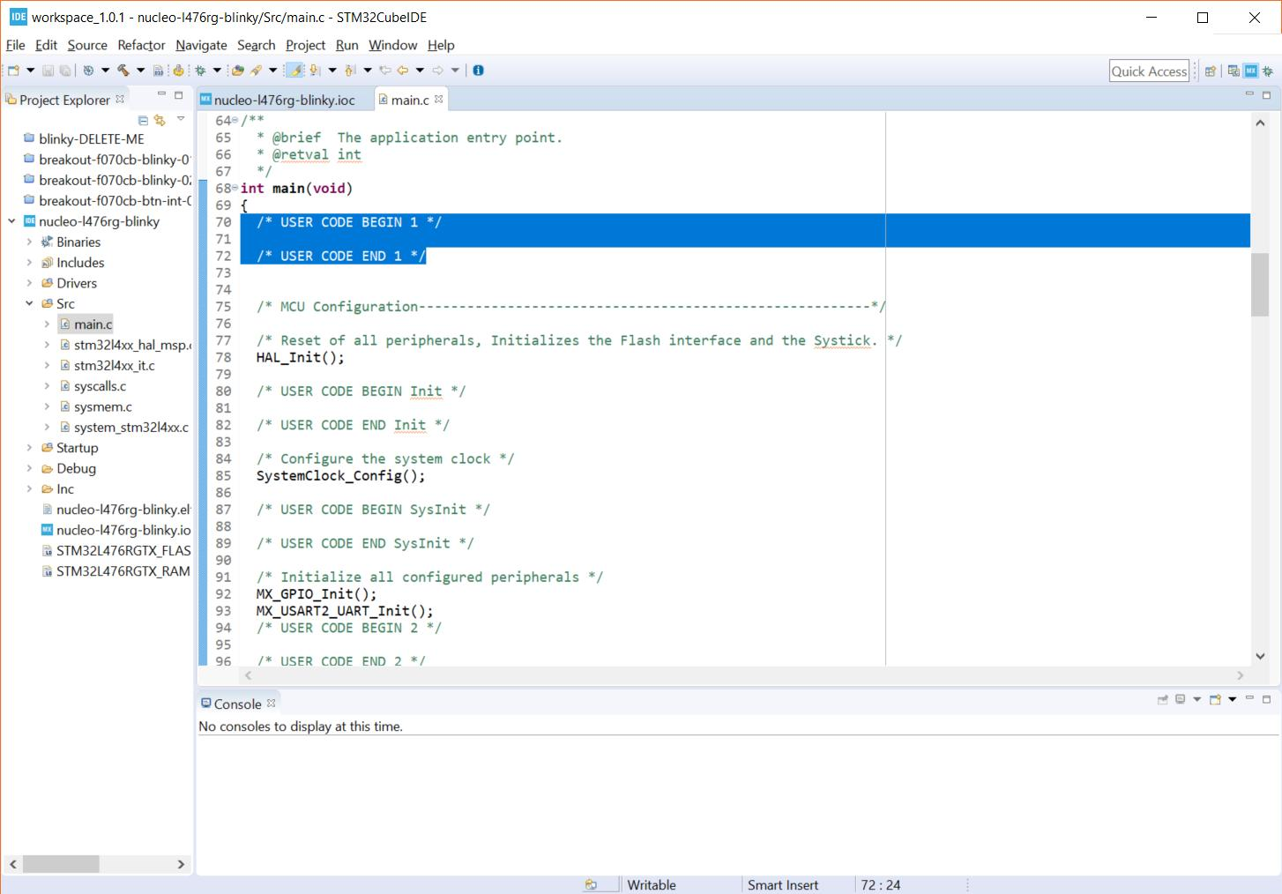
Code Editor
Used to read and edit C source files. We'll understand this environment, but write our firmware in Keil.
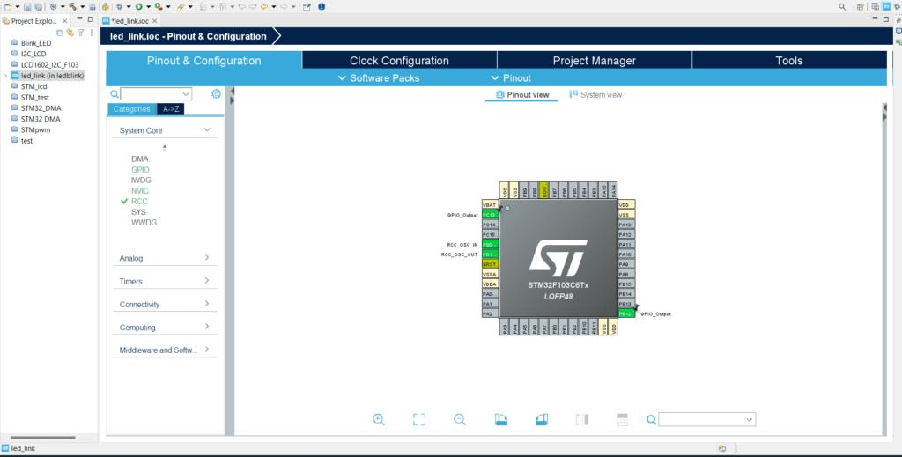
Device Configuration
Used to configure GPIO, clocks and peripherals through the graphical interface.
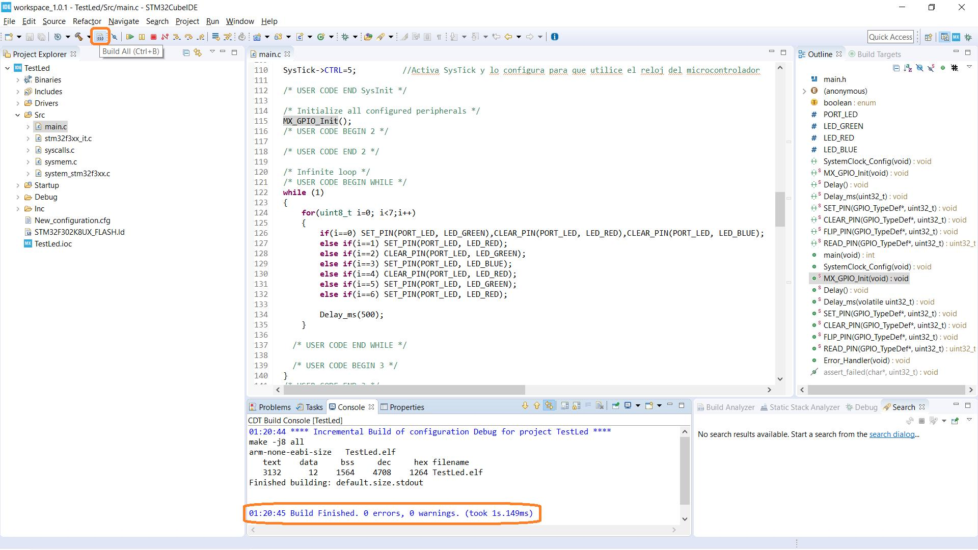
Console and Problems
Display compilation output, warnings, errors and other diagnostic information.
3. How it fits into our workflow
STM32CubeIDE
Understand project structure and configuration
Keil µVision
Write, compile and link our firmware
Proteus
Load and simulate the firmware
These are separate tools. CubeIDE's generated projects are not automatically interchangeable with every Keil project. We'll use compatible startup files, device definitions and libraries when needed.
4. What you should understand today
- An IDE integrates multiple development tools.
- STM32CubeIDE includes CubeMX configuration functionality.
- The project explorer organizes firmware files.
- The compiler and linker perform different jobs.
- The debugger helps inspect firmware execution.
- Understanding CubeIDE does not require using it to write our firmware.
Quick checkpoint
Q1. What is the primary purpose of STM32CubeMX?
Compile C code
Configure peripherals and clocks
Debug machine instructions
Correct
CubeMX provides graphical MCU configuration and code generation.
Q2. Which tool will we use to write and compile our firmware?
Proteus
STM32CubeIDE
Keil µVision
Correct
Keil µVision is our primary coding and build environment.
Q3. What is the linker's main responsibility?
Combine object files and arrange memory sections
Configure GPIO pins
Simulate the microcontroller
Correct
The linker combines compiled objects and places sections according to the memory layout.
3 of 3 answered

